Node js javascript runtime environment

Not library no framewkork

* We are creating our own servers/web applicatiomn by writing plain js code
* When we want to send a request to any server we need its **url**

http://localhost:9500

http://localhost:9500/factorial

<http://localhost:9500>/login

Routing ---based on url we need to process request differently and send different different response on each url

2 ways to include module in JS file. First one is require function.

Import statement. They can just take out of the function. From any other JavaScript file. So for example if I have 100 function, I have to import only one function then I will use import statement.

Import {functions} from ‘package-name’

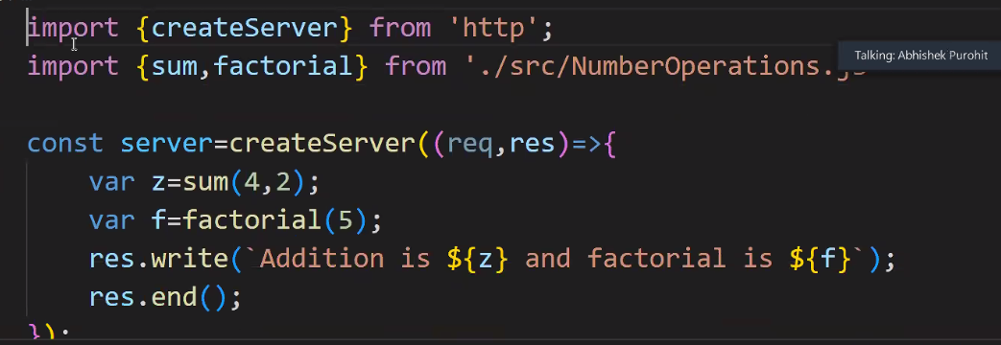

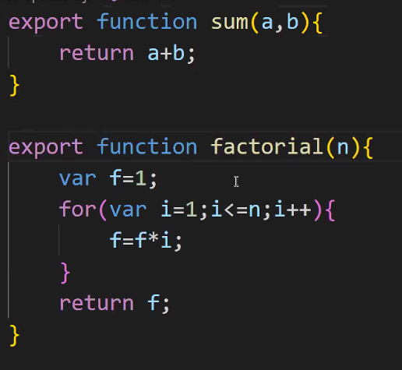

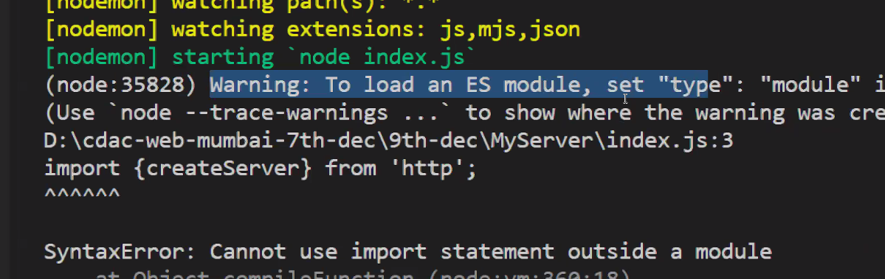

ES std- echma std instead os common js std

Include type as module

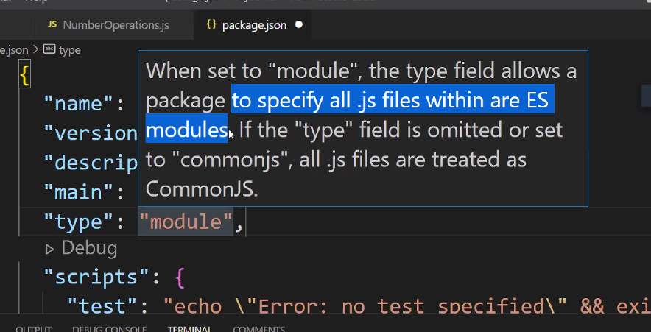

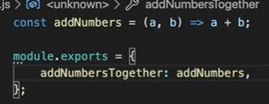

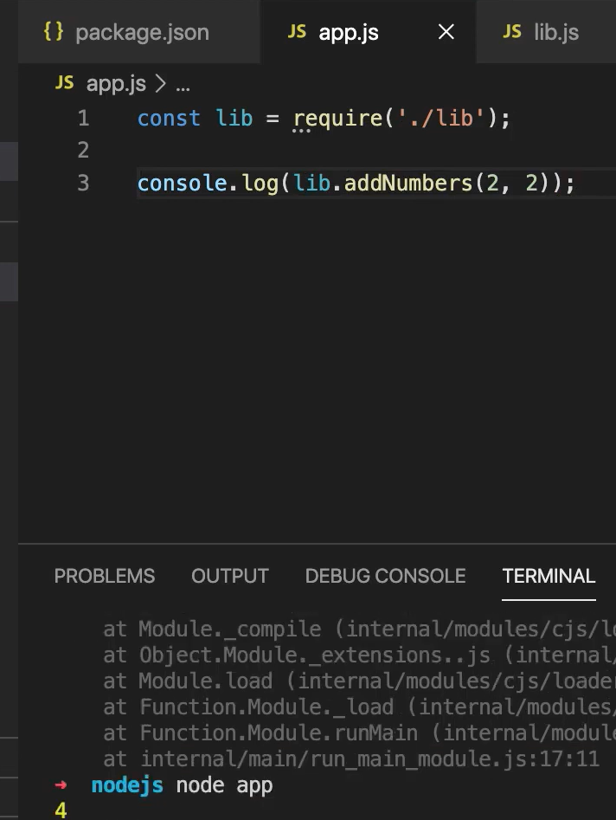 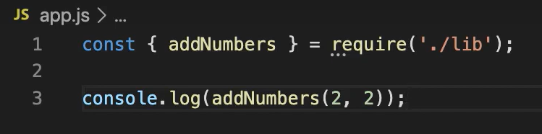

EXPRESS FRAMEWORK

MAKE PACKAGE..JSON

INSTALL EXPRESS LOCALLY

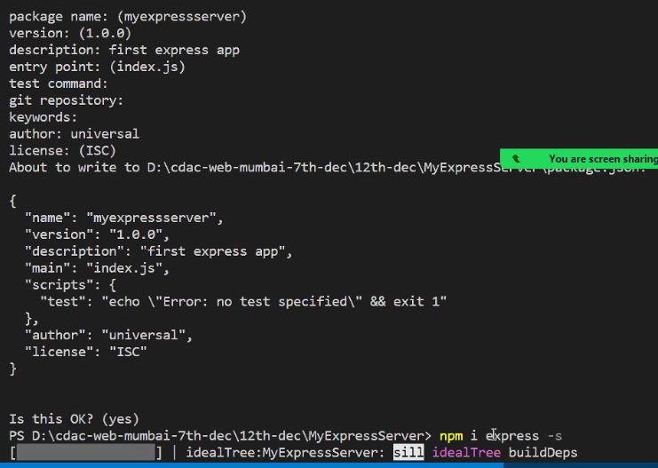

Whenever we want to import total folder then write on the

SYNTAX------import reference from ‘module’

import express from Express.

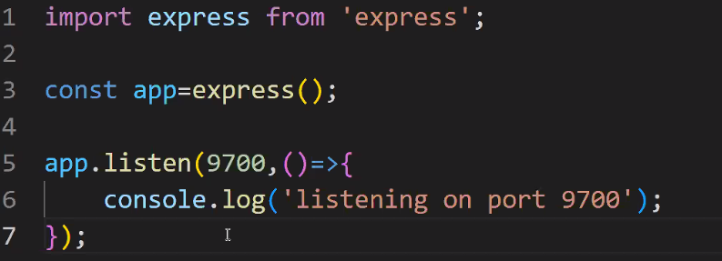

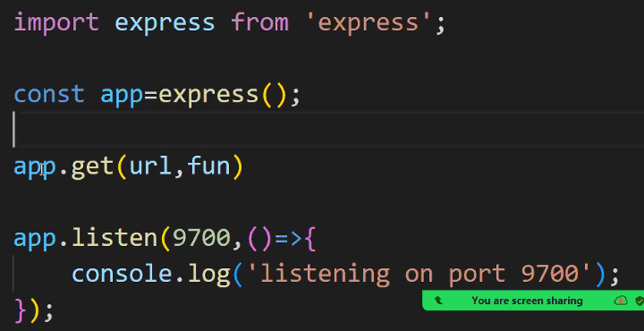

ON OUR on our application, if there is GET request on URL one, the function one will be created.

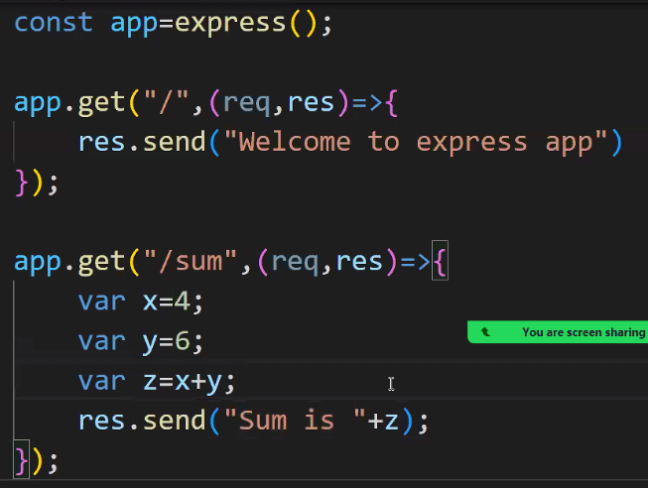

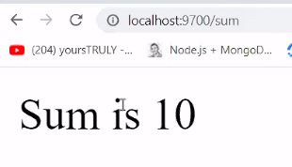

If we want to take values from url

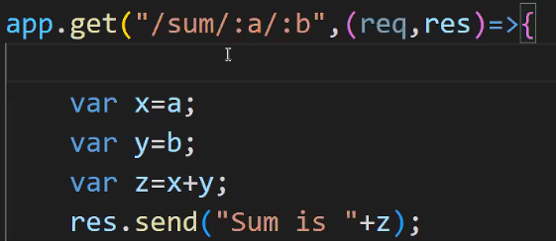

We cannot do like this

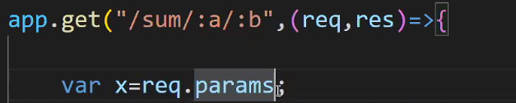

It will give JSON obj



Just like this we have to access

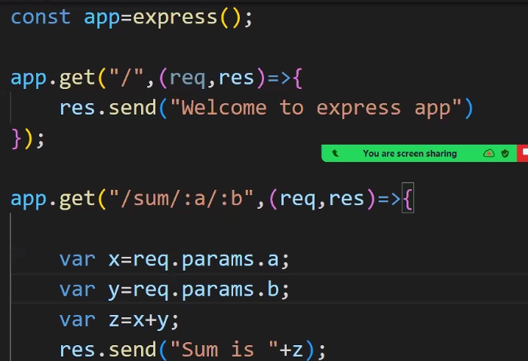

It will concat the both no we have to parse

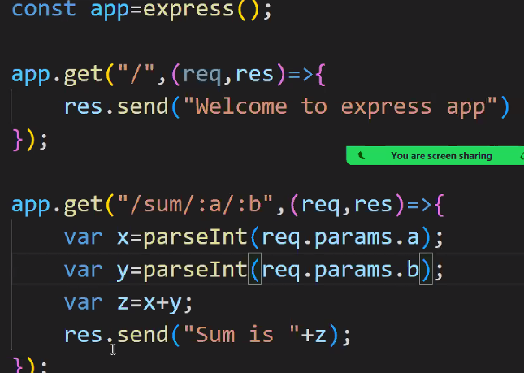

If our data is to be secure like in banking case

When we are sending a request on server. And we need. To send some data also. Show me just need to pass the data in request body. If we don’t want to send data on URL then use request body.

GET method will not work

Postman : api client

Low weight ----🡪Thunder client

We have to use POST

Request bodies and undefine.